API Documentation

/idcreate API

|  |  |
| --- | --- |
| Method | POST |
| Endpoint | idcreate |
| Description | Creates session id for owner and user |

Request:

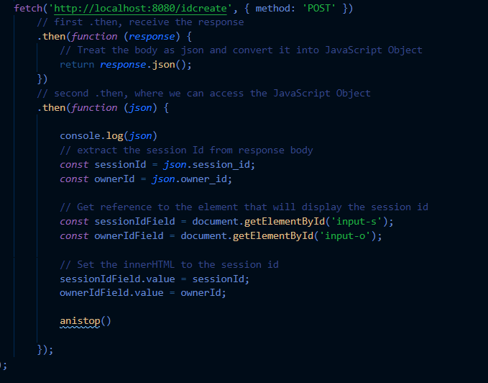

Response:

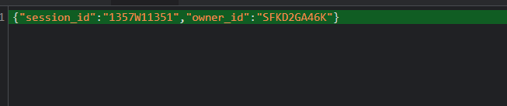

/go API

|  |  |
| --- | --- |
| Method | GET |
| Endpoint | go |
| Description | Goes to the question page(for a normal user) |

Request:

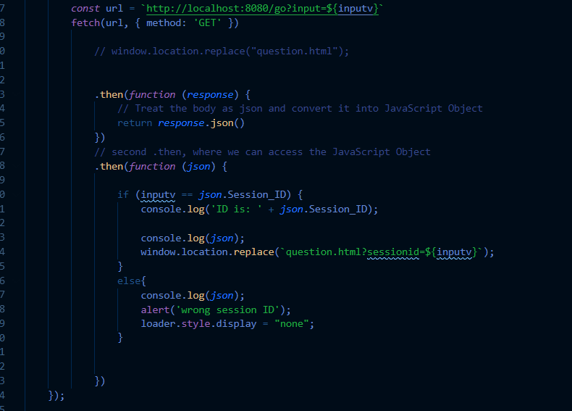

Response:

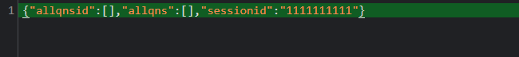

/mgo

|  |  |
| --- | --- |
| Method | GET |
| Endpoint | mgo |
| Description | Goes to the question page(for owner) |

Request:

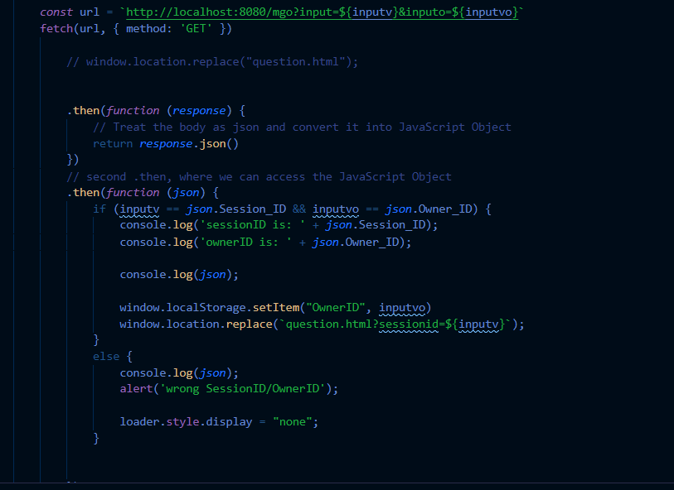

Response:

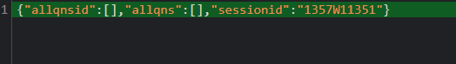

/getqns

|  |  |
| --- | --- |
| Method | GET |
| Endpoint | getqns |
| Description | When user refresh/load the page for the particular session |

Request:

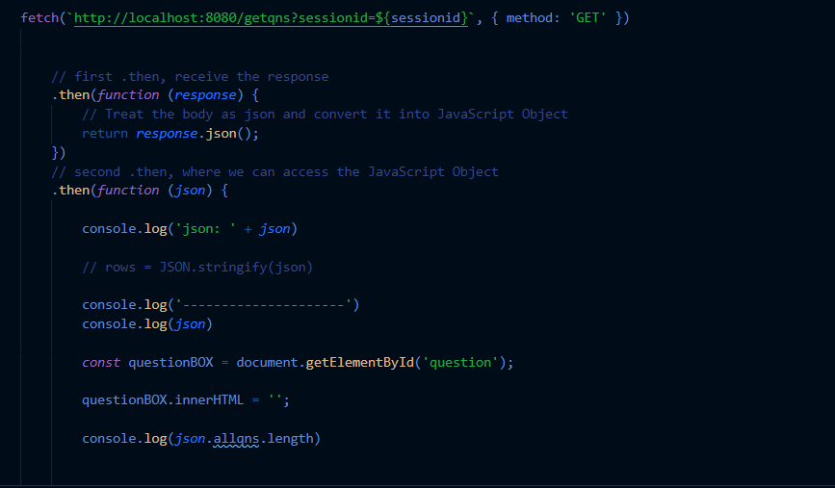

Response:



/createqns

|  |  |
| --- | --- |
| Method | POST |
| Endpoint | createqns |
| Description | When user posts a question. |

Request:

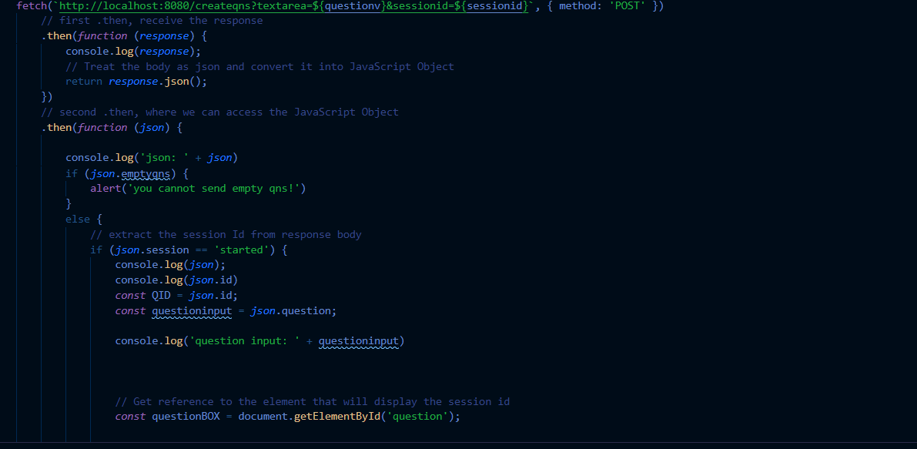

Response:



/startsession

|  |  |
| --- | --- |
| Method | PUT |
| Endpoint | startsession |
| Description | The owner starts the particular question that was created. |

Request:

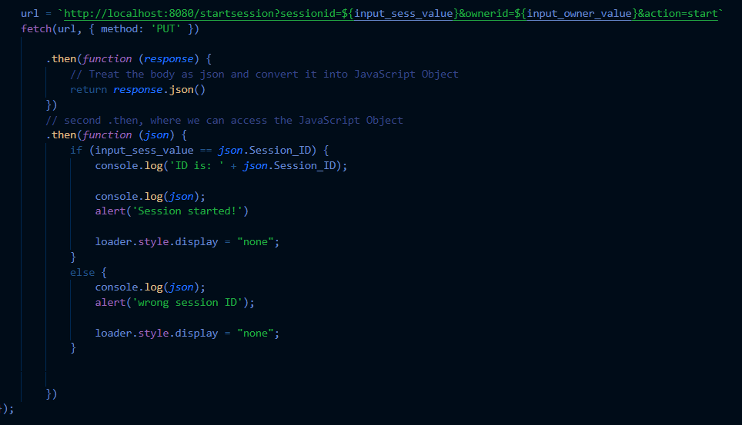

Response:

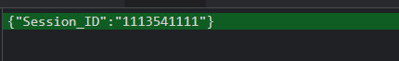

/stopsession

|  |  |
| --- | --- |
| Method | PUT |
| Endpoint | Stopsession |
| Description | The owner stops the particular question that was created. |

Request:

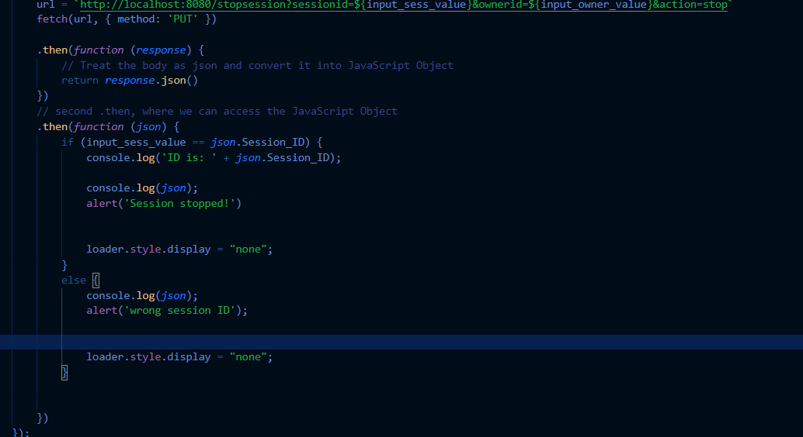

Response:



/ansqns

|  |  |
| --- | --- |
| Method | PUT |
| Endpoint | ansqns |
| Description | To allow the owner to question that was asked. |

Request:

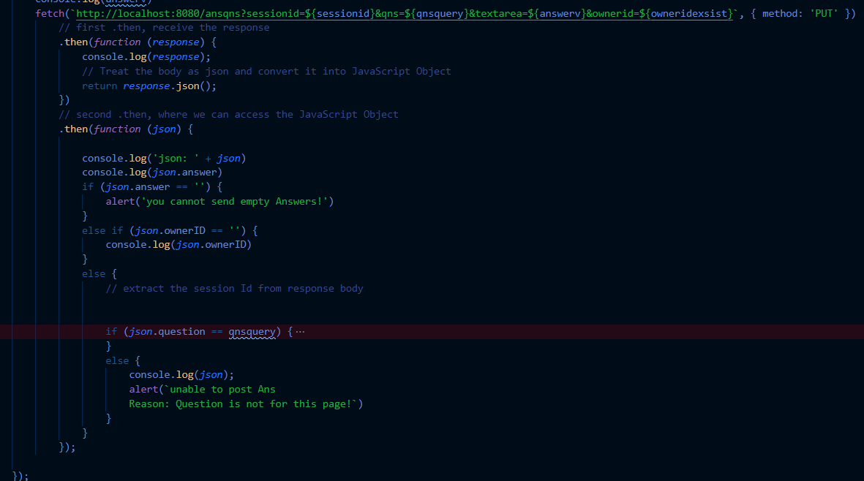

Response:

